14.2 Editors - Movie Clip Editor - Tool shelf
Tool Shelf 1
Track Tab and Solve Tab in Tracking Mode 1
Annotation tab 1

Tool Shelf
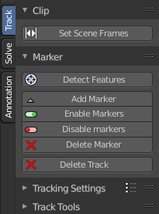
The Tool Shelf exists for the Tracking Mode in Clip submode. And for Mask mode.

In Tracking Mode it contains the tools to do the tracking. And in Mask Mode some mask tool functionality.

The submodes Graph and Dopesheet does not have a tool shelf. Here you can find a list of the tracks instead.

The content is differing, dependant of the mode you are in. Tracking mode has other tools than the Masking mode.

Track Tab and Solve Tab in Tracking Mode

The track tab contains the tools around the movie side of things. Markers, tracking etc.

The solve tab contains the tools around the scene side of things. Scene setup, camera motion, etc.

Annotation tab
The Annotation tab contains the usual Annotation tools like in some other editor types.

